1. Write a pig script to find the top 20 destination people travel the most.

DATA LOAD

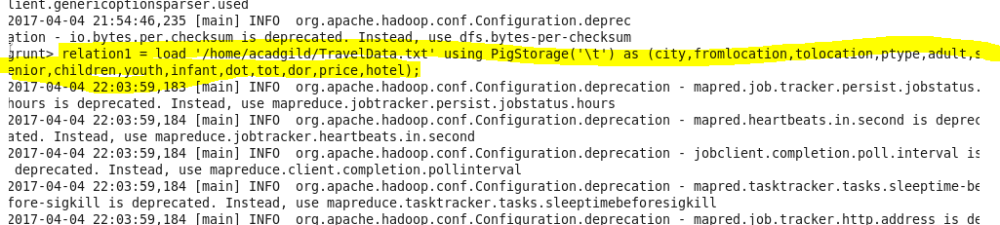

GROUP BY DESTINATION

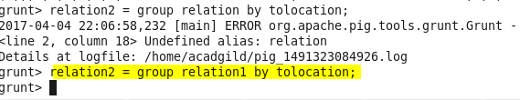

COUNT OPERATION

Capture3.PNG

ORDER IN DESC

Capture4.PNG

LIMIT BY 20

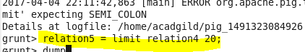

DUMP THE RESULT by

dump relation5;

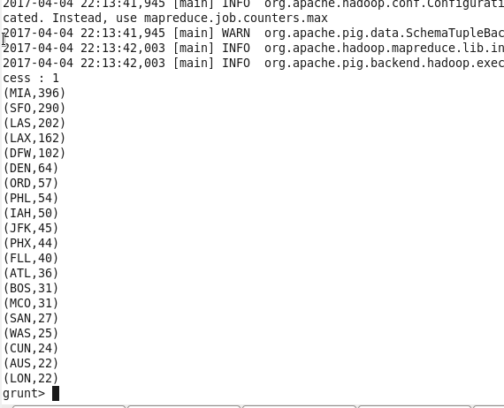

1. Write a pig script to find the top 20 locations from where people travel the most.

DATA LOAD



GROUP BY fromloc

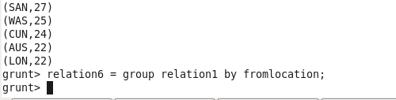

COUNT OPERATION

Capture8.PNG

ORDER IN DESC

Capture9.PNG

LIMIT BY 20

Capture10.PNG

DUMP result by

dump relation9;

